Name: _____________________________ Date: _______

Background: During the 1920s, the U.S. experienced a massive amount of change. For the first time in history, a majority of Americans left rural areas and moved to cities. This was very disturbing and shocking to many who lived in small towns or farms. Rural Americans could understand why people would be interested in the city; its bright lights and excitement. But, this only added to their distrust and fear of city life. Some Americans feared their “culture” was being lost to cities. Traditionalist, rural values were now being replaced by modernity. Modernists embraced jazz, materialism and new ways of thinking and styles. Automobiles, radios, movies, advertising, and new realities of modern life were spreading. | 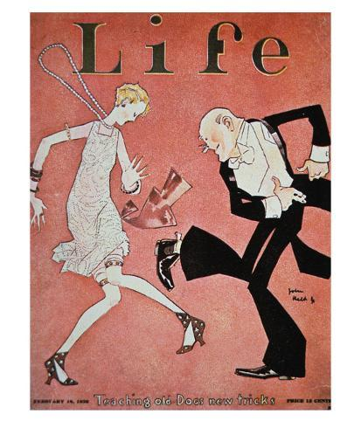
These were viewed as dangerous and ‘sinful’ to traditionalists and gave rise to culture wars in American society. These “battles” were fought in newspapers, schools, churches, movies, music, radio and political campaigns. Enter the “speakeasy” to learn more about these culture wars. By clicking on items, you will be brought to a slide with a video and information on that culture war. Take notes where appropriate on the different arguments! 😊
... Where evolution and science conflicts with The Bible.

Modernists: | Traditionalists:

... Where immigration was contested and debated.

Immigrants: | Nativists:

... People moving from farms to cities for economic opportunities.

Urban: | Rural:

... Cultural conflicts over the 18th Amendment known as Prohibition.

Wets: | Drys:

... Racially motivated violence contrasted with the Jazz Age.

Equality: | Hate:

Reflect: What social, economic, or political changes did you observe in the 1920s? How did this shape the United States? Answer below.

__________________________________________________________________________________________________________________________________________________________________________________________________________________________________________________________________________________________________________________________________________________________________________________________________________________________________________________________________

